

Team Name

**The Three-Body Problem**

Team Members

**Bei Zhang**

**Ruochen Geng**

**Yao Lu**

November 13, 2018

**Table of Contents**

Executive Summary 3

Data Description 4

Data Cleaning Process 7

Variables Used 9

Variables Transformation 9

Standardization and Dimension Reduction (PCA) 10

Model Algorithms 12

Mahalanobis Distance 12

Autoencoder 13

Combined Fraud Scores 15

Results 16

Conclusions 18

Appendix: Data Quality Report 19

**Executive Summary**

The goal of this project is to identify potential fraudulent records in the New York City property data through unsupervised machine learning models and to analyze some of the examples of top fraudulent records identified by the algorithms.

The dataset consists of over 1 million records of properties in New York City which includes information about the location, usage classification, lot and building sizes and assessed values. Since property taxes are strongly related to the assessed value of the property, the actual value of the property could be misrepresented for tax evasion purposes. For the fraud analysis, many of the factors such as building and lot size, together with the geographical location have been put into consideration when considering the accuracy of the final property value.

The following methods have been applied to the data to determine if the assessed value of the property had been misrepresented. The data had been standardized and components were isolated using PCA (principal component analysis). From there, an autoencoder and mahalanobis distance algorithms have been applied to the data to determine whether a given data entry is an outlier compared to the general trends. Each algorithm has assigned a fraud rank to the data, and the ranks have been combined to get a more accurate result. Both algorithms gave very similar results to entries that have been deemed more fraudulent, and vice versa.

Finally, the top 10 outlier entries were further analyzed to determine how they might have been flagged as a fraudulent record by both algorithms, and to estimate whether they were possibly erroneously entered or fraudulently misrepresented.

**Data Description**

This part provides data description for New York property data in November 2010. There are 1,048,575 records and 30 fields in the data.

**Numeric variables:**

|  |  |  |  |  |  |  |  |  |
| --- | --- | --- | --- | --- | --- | --- | --- | --- |
| **#** | **variable** | **count** | **mean** | **std** | **min** | **max** | **% populated** | **0 value** |
| 1 | **LTFRONT** | 1048575 | 36 | 74 | 0 | 9999 | 100 | 168867 |
| 2 | **LTDEPTH** | 1048575 | 88 | 75 | 0 | 9999 | 100 | 169888 |
| 3 | **STORIES** | 996433 | 5 | 8 | 1 | 119 | 95.03 | 0 |
| 4 | **FULLVAL** | 1048575 | 880488 | 11702927 | 0 | 6.15E+09 | 100 | 12762 |
| 5 | **AVLAND** | 1048575 | 85995 | 4100755 | 0 | 2.67E+09 | 100 | 12764 |
| 6 | **AVTOT** | 1048575 | 230758 | 6951206 | 0 | 4.67E+09 | 100 | 12762 |
| 7 | **EXLAND** | 1048575 | 36812 | 4024330 | 0 | 2.67E+09 | 100 | 484224 |
| 8 | **EXTOT** | 1048575 | 92544 | 6578281 | 0 | 4.67E+09 | 100 | 425999 |
| 9 | **EXCD1** | 622642 | 1605 | 1388 | 1010 | 7170 | 59.38 | 0 |
| 10 | **ZIP** | 1022219 | 10935 | 527 | 10001 | 33803 | 97.49 | 0 |
| 11 | **BLDFRONT** | 1048575 | 23 | 36 | 0 | 7575 | 100 | 224661 |
| 12 | **BLDDEPTH** | 1048575 | 40 | 43 | 0 | 9393 | 100 | 224699 |
| 13 | **AVLAND2** | 280966 | 246365 | 6199390 | 3 | 2.37E+09 | 26.8 | 0 |
| 14 | **AVTOT2** | 280972 | 716079 | 11690165 | 3 | 4.5E+09 | 26.8 | 0 |
| 15 | **EXLAND2** | 86675 | 351802 | 10852484 | 1 | 2.37E+09 | 8.27 | 0 |
| 16 | **EXTOT2** | 129933 | 658115 | 16129808 | 7 | 4.5E+09 | 12.39 | 0 |
| 17 | **EXCD2** | 90941 | 1372 | 1105 | 1011 | 7160 | 8.67 | 0 |

**Categorical Variables:**

|  |  |  |  |  |  |
| --- | --- | --- | --- | --- | --- |
| **#** | **variable** | **# NaN** | **# unique** | **% populated** | **most common value** |
| 1 | **BBLE** | 0 | 1048575 | 100 | 4017830023 |
| 2 | **BLOCK** | 0 | 13949 | 100 | 3944 |
| 3 | **LOT** | 0 | 6366 | 100 | 1 |
| 4 | **EASEMENT** | 1044532 | 12 | 0.39 | E |
| 5 | **OWNER** | 31083 | 847053 | 97.04 | PARKCHESTER PRESERVAT |
| 6 | **BLDGCL** | 0 | 200 | 100 | R4 |
| 7 | **TAXCLASS** | 0 | 11 | 100 | 1 |
| 8 | **STADDR** | 641 | 820637 | 99.94 | 501 SURF AVENUE |
| 9 | **EXMPTCL** | 1033583 | 14 | 1.43 | X1 |
| 10 | **PERIOD** | 0 | 1 | 100 | FINAL |
| 11 | **YEAR** | 0 | 1 | 100 | 2010/11 |
| 12 | **VALTYPE** | 0 | 1 | 100 | AC-TR |

As seen from the table, apart from the missing values, there is a large amount of data with 0 values, which is obviously abnormal. Thus, we will regard them as missing values and fill in those values in the next step. Important parts of process are shown below:

* The property data includes geographical information:
  + ZIP the zip code for the property.
  + BBLE is the concatenation of BORO, BLOCK, LOT, EASEMENT and it is unique for each record.
  + BLOCK shows valid block ranges by BORO.
  + LOT is the unique number of the property within BORO/BLOCK.
  + EASEMENT is used to describe easement.
* Each property’s physical information:
  + LTFRONT and LTDEPTH: lot frontage and depth
  + BLDFRONT and BLDDEPTH: building frontage and depth
* Regulatory information:
  + TAXCLASS: Tax class
  + BLDCLASS: Building class. There is a direct correlation between the Building Class and the 1st position of the Tax Class.
  + OWNER: property owner’s name
* Core variables in fraud detection (the distribution plot is attached):
  + FULLVAL: total market value of the property.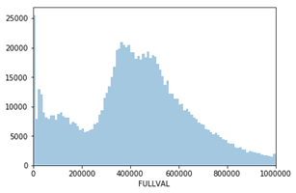
  + AVLAND: The total land area.

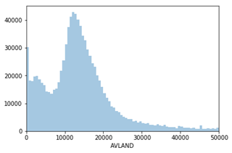

* + AVTOT: Assessed value of the property.

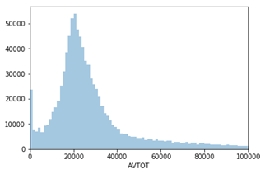

More details of each variable can be seen in the Appendix (Data Quality Report)

**Data Cleaning Process**

We need to use 9 fields that contain missing values (or 0 values) to create variables. We fill in the missing values in the following steps.

**ZIP:**

2.51% of the records do not contain a ZIP in the dataset.

We sort all the records by BBLE and use the ZIP from the previous property to fill in the missing values. BBLE is the combination of BORO, BLOCK and LOT information of the property. Properties with similar BBLE (similar BLOCK) are located close to each other so that they have the same ZIP.

**LTFRONT & LTDEPTH:**

For entries that have either one of LTFRONT/LTDEPTH, we take the average ratio, and derive the missing value from that, since they are highly correlated (Pearson correlation of 0.486).

For the remaining entries, we look at the mean LTFRONT/LTDEPTH values grouped by BOROUGH and TAXCLASS.

**BLDFRONT & BLDDEPTH:**

For entries that have either one of BLDFRONT/BLDDEPTH, we take the average ratio, and derive the missing value from that, since they are highly correlated (Pearson correlation of 0.60).

For the remaining entries, we look at the mean BLDFRONT/BLDDEPTH values grouped by BOROUGH and TAXCLASS.

**STORIES:**

To fill in the missing values for field STORIES, we assume that the average price per square feet is similar among properties with the same ZIP and same TAXCLASS. (There is a direct correlation between the Building Class and the 1st position of the Tax Class.)

Therefore, we group all the records by ZIP and then TAXCLASS and calculate the average STORIES (not include missing value) for each group.

Then, we replace the missing value by the average STORIES of its group.

**FULLVAL:**

To fill in the missing values for field FULLVAL, we assume that the average price per square feet is similar among properties with the same ZIP.

Therefore, we first calculate the average price per square feet for all the records that contains FULLVAL:

average price per square feet = FULLVAL/(STORIES* BLDFRONT * BLDDEPTH)

Second, we group all the records by ZIP and calculate the mode of average price per square feet within one ZIP. Let us call it ‘mode price per square feet of ZIP’.

Then, we use ‘mode price per square feet of ZIP’ to calculate the FULLVAL for the properties with missing value:

FULLVAL = (STORIES * BLDFRONT * BLDDEPTH) * mode price per square feet of ZIP

**AVLAND & AVTOT:**

Since this is an assessed tax value, it is grouped by BOROUGH, TAXCLASS, lot size and building size (for AVTOT). The average AVLAND/AVTOT values are taken.

**Variables Used**

**Variables Transformation**

1. Create 3 sizes: LOTAREA, BLDAREA and BLDVOL

There are three target values: FULLVAL, AVLAND and AVTOT, which stands for total market value of the land, assessed land value and assessed total value respectively. To normalize these three values, we will create 3 sizes using existing variables:

· Lot area: LOTAREA = LTFRONT * LTDEPTH

· Building area: BLDAREA = BLDFRONT * BLDDEPTH

· Building volume: BLDVOL = BLDAREA * STORIES

1. Calculate 9 core variables

Intuitively, land value usually has a positive relationship with the area of the lot, building and the volume of building. In this way we then normalize FULLVAL, AVALAND and AVTOT by these three sizes (e.g. FULLVAL/ LOTAREA) and derive each land value per unit. This step creates another 3 * 3, which is 9 variables.

1. Calculate another 54 variables

Finally, we take advantage of several entities in the data to further scale the 9 core variables. The entities include ZIP, ZIP3 (first 3 digits of the ZIP), TAXCLASS, BORO and STORIES. The basic intuition here is that within the same entity group mentioned above indicating geographical location, property tax class and building structure, the difference among land values is not significant. After each of the record is divided by certain entity group average, the deviation of value from the average level could be captured. What is worth mentioning in the preprocessing step is that we have transformed STORIES into 10 bins instead of the nominal value.

To be more specific, first, we calculate averages grouped by each of 5 entities and also the combination of BORO and TAXCLASS. By considering location and tax class at the same time, we can get more reasonable averaged land values. From the perspective of feasibility, there are 11 unique tax classes and 5 unique borough codes. This total group number 55 helps to nicely divide the target values. Secondly, divide each of the 9 core variables by the 6 scale factors from these groupings.

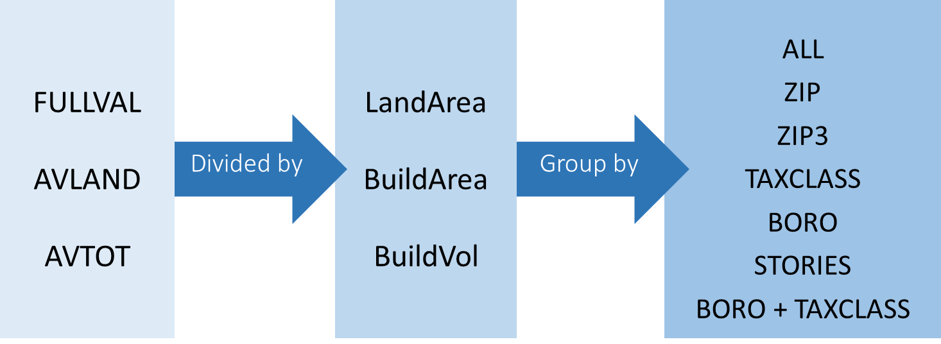

Thus, there are 3 * 3 * 7 = 63 new variables in all calculated through this step to be put in our unsupervised model later.

**Standardization and Dimension Reduction (PCA)**

**Variable Standardization**

As our 63 variables are in different scales, we need to standardize them in order to make a better comparison. Here we use the z-scaling method, which ensures linearly transformed data values having a mean of zero and a standard deviation of 1. To standardize a variable, subtract the mean and divide by the standard deviation. The formula used is shown below:

Where is the variable, is the mean, is the standard deviation.

**Principal Component Analysis**

As we calculate 54 variables by using the 9 core variables, it is possible that variables are correlated more or less. Therefore, we use PCA to remove these correlations and achieve a reduction in dimensions. Principal Component Analysis (PCA) is a tool used to reduce a large set of variables to a small set that still contains most of the information in the large set. The first principal component accounts for as much of the variability in the data as possible, and each succeeding component accounts for as much of the remaining variability as possible. Generally speaking, the number of components we choose should can explain for 80% - 90% variance of data. So we next look at the cumulative explained variance ratio as a function of the number of components:

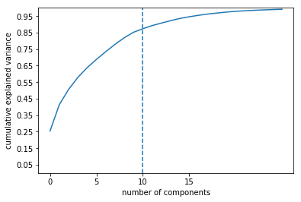

|  |  |
| --- | --- |
|  | Percentage of explained variance |
| PC1 | 25.44% |
| PC2 | 15.94% |
| PC3 | 9.26% |
| PC4 | 7.29% |
| PC5 | 5.87% |
| PC6 | 4.99% |
| PC7 | 4.67% |
| PC8 | 4.42% |
| PC9 | 4.03% |
| PC10 | 3.32% |

To ensure more than 85% of the variance is explained, we choose to include the first 10 components, which can account for 85.23% of the variance. PC 1 can explain up to 25.44% of the variation, and PC 2 has 15.94%.

**Principal Component Standardization**

Finally, the principal components chosen have to be scaled using Z-scale method again to ensure those 10 components are comparable before being put into the model. Thus, the transformed shape of PC data contains 1048575 records and 10 columns.

**Model Algorithms**

**Mahalanobis Distance**

The first way that we use to determine outliers is the Mahalanobis distance method. The mahalanobis distance *D* is a measure of how far away any given point *p* is from the center *C*. Instead of the euclidean distance, the mahalanobis distance gives the number of standard deviations a point is from the center with the spread of each axis put into consideration.

Given that the dataset has already been broken down into each principal component, all that is required to obtain the mahalanobis distance is to standardize the number and measure the deviations in euclidean distance.

For each data point , which has principal components, each principal component has been scaled down to a standardized z-score. The z-scores have been combined using the root sum squared. The method used for the mahalanobis distance is shown below:

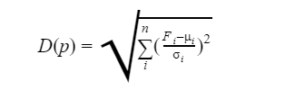

where is the number of selected principal components and is each principal component. The following plot shows the distribution of the mahalanobis distance representing fraud scores that have been assigned to each entry. A smaller score represents lower likelihood of fraud and vice versa.

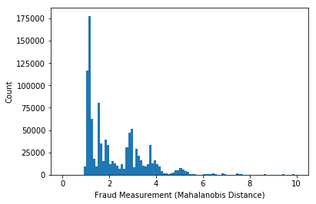

**Autoencoder**

An autoencoder learns to compress data from the input layer into a short code, and then decompresses that code into something that closely matches the original data. In this project, we use the simplest form of an autoencoder. It has an input layer, an output layer (decoder layer) and one hidden layer (encoder layer).

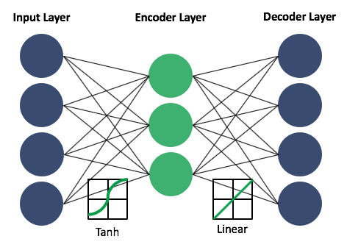

**Input layer**

The first layer is the input layer. The input dimension is 10, which is the number of principal components we have chosen from PCA.

**Encoder layer**

The autoencoder consists of two parts, the encoder and the decoder. The encoding dimension is that same as the input dimension divided by the compression factor. In this case, we set the compression factor as 1.1. The reason we choose a relatively small compression factor is that we have already performed a dimensionality reduction in PCA. We have also tried larger compression factors, but the results however are not as ideal as 1.1.

We use the **tanh activation function** in the encoder layer. There are three reasons. Firstly, we need a non-linear activation function in order to differentiate the autoencoder model from the previous model and learn the non-linear relationships. Secondly, our labels (the output from PCA) contain both positive and negative numbers. Therefore, we want the output from the encoder layer to also contain positive and negative numbers since the output range of tanh activation function is (-1, 1). Thirdly, the tanh function is chosen since it is the most simple activation function that satisfies all the previous requirements.

**Decoder layer**

The output layer has the same **number of nodes** as the input layer with the purpose of reconstructing its own inputs.

We use a **linear activation function** in the decode layer because we want the range of output to be from negative infinity to positive infinity (the same as PCA output). And the linear activation function is the simplest.

**Optimizer**

We tried several optimizers and adadelta performs the best.

**Loss function**

We use the mean square error (MSE) as the loss function. Since we only want to consider regression loss functions and the MSE function performs the best among all the regression loss functions.

**Fraud score calculation and distribution**

After using the autoencoder to reproduce a matrix of PCA, we compare the input matrix and the output matrix and calculate the difference. The metrics we tried include mean absolute error, mean square error and root sum squared with different values for n.

After plotting the distributions of all errors, we find the distribution of MSE is the best. The errors of most records are right-skewed, meaning that fraud scores of most records are very low. Thus, the fraud records are easier to detect. Therefore, we use MSE as our fraud score for the autoencoder. We also compared different fraud rankings using three metrics. The rankings are the same for MAE, MSE and root sum squared.

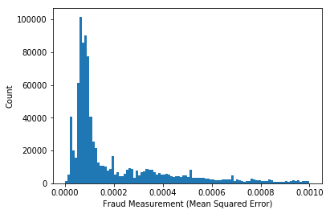

**Combined Fraud Scores**

After both fraud scores from the autoencoder and mahalanobis distance have been assigned to each entry in the data, a ranked value had been assigned for both fraud scores to each entry. Two values (*MahalRank* for Mahalanobis distance and *AERank* for AutoEncoder) have been assigned to represent a fraud score where a higher rank number would represent a higher likelihood of fraud and vice versa.

For a comparison of performance of both methods, the data has been sorted in ranked order and the amount of overlapping entries within each portion of entries. For the top 1% (10,000 entries) of the highest fraud score entries, there is a 49% overlap between the two fraud scores. On the other hand, for the bottom 1% of the which represent the lowest fraud scores, there is only a 9% overlap between the two fraud scores.

In conclusion, since both fraud scores have been given the same weight, the combined score used is simply a mean of both fraud ranks. By using the mean of two ranks, it gives no bias to either ranking system, and at the same time, does not provide a higher than necessary chance of false positives and a lower than necessary chance of false negatives.

**Results**

|  |  |  |  |  |  |  |  |  |
| --- | --- | --- | --- | --- | --- | --- | --- | --- |
|  | RECORD | LTFRONT | LTDEPTH | STORIES | FULLVAL | M’s Distance  Rank | Auto  Encoder  Rank | Combined  Rank |
| 1 | 632817 | 100 | 100 | 2.5 | 330000 | 1 | 1 | 1 |
| 2 | 126405 | 159 | 159 | 2 | 817000 | 2 | 2 | 2 |
| 3 | 126400 | 131.2 | 131.2 | 6 | 175778 | 3 | 3 | 3 |
| 4 | 138830 | 100 | 100 | 3 | 800000 | 4 | 4 | 4 |
| 5 | 585119 | 100 | 100 | 2 | 340000 | 5 | 5 | 5 |
| 6 | 108897 | 100 | 100 | 2 | 700000 | 6 | 6 | 6 |
| 7 | 85887 | 101 | 101 | 31 | 281677 | 7 | 7 | 7 |
| 8 | 918306 | 100 | 100 | 2 | 370000 | 8 | 8 | 8 |
| 9 | 934794 | 100 | 100 | 2.7 | 419000 | 9 | 10 | 9.5 |
| 10 | 934781 | 131.2 | 131.2 | 16 | 158864 | 10 | 11 | 10.5 |

1. **111-15 212 STREET**

FULLVAL is cheaper than average (372000) with same ZIP, same STORIES and BLOCK

1. **141-37 13 AVENUE**

FULLVAL is cheaper than average (880000) with same ZIP, same STORIES and BLOCK

1. **350 EAST 30 STREET**

Big lot area

1. **25-88 48 STREET**

FULLVAL is more expensive than average (730000) with same ZIP, same STORIES and BLOCK

1. **81-59 102 AVENUE**

FULLVAL is cheaper than average (446000) with same ZIP and same STORIES

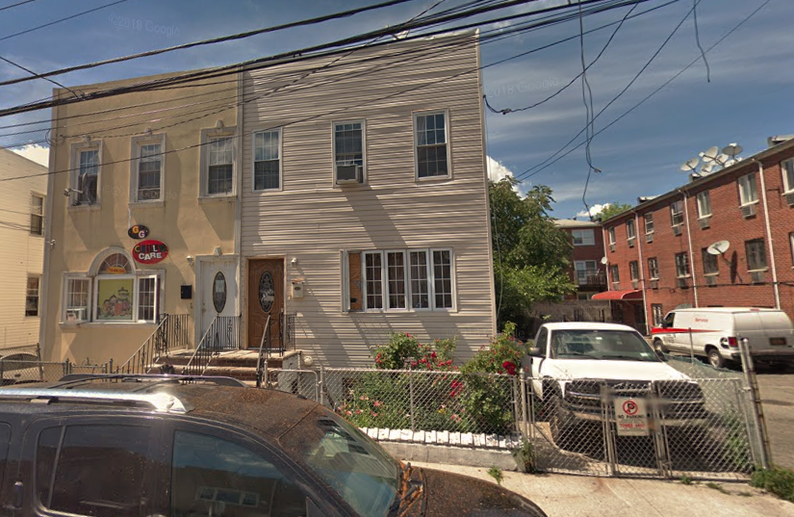

1. **2059 62 STREET**

FULLVAL cheaper than average (724068), taxclass C3

1. **30 WEST 61 STREET**

31 Story building, BLDVOL does not match

1. **336 Underhill Ave Bronx NY**

LTFRONT is a lot smaller than listed 100

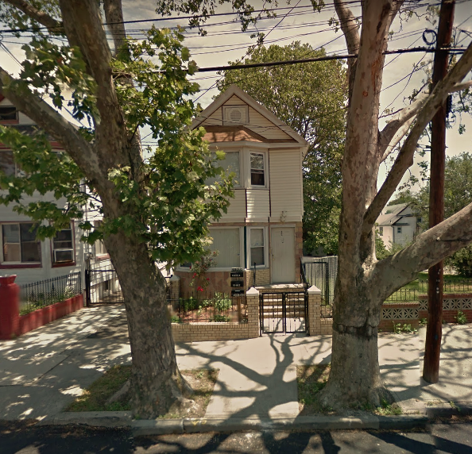

1. **221-15 FAIRBURY AVENUE**

FULLVAL is cheaper than average (435000) with same ZIP and same STORIES

1. **41 WEST 72 STREET**

FULLVAL is cheaper than average (200000) with same STADDR and same STORIES

**Conclusions**

In this project, we went through data exploratory analysis, data cleaning and feature selection and feature engineering before building the algorithms. Then we use the two algorithms to evaluate the fraud level of all records and combine the results of the two algorithms. In the end, we manually look at the suspicious records and analyze them in detail.

The fraud score distributions of the two algorithms are seriously right-skewed, which means most of the records are not fraudulent. Meanwhile, most of the top ten records we selected are unusual and are not just data errors.

We still have future work if we have more time. First, we do not use variables with a lot of missing values, such as EXTOT, in this project. We would like to explore whether these variables have impact on fraud scores. Second, we would like to explore the relationship between ‘OWNER’ and fraud score. Third, currently we are using ‘tanh’ as encode layer activation function and ‘linear’ as decode layer function. We would like to try more advanced activation functions such as LeakyRelu. Also, we would like to try more advanced algorithms such as convolutional autoencoder.

**Appendix: Data Quality Report**

**Continuous Variables**

|  |  |  |
| --- | --- | --- |
| **Variable** | **Dtype** | **Description** |
| LTFRONT | Int64 | Lot Frontage in feet. No null values. Zero-value represents a large proportion. |

Top 5 frequent values and counts:

0 168867

20 134447

25 116301

40 81802

18 40188

The distribution plot is shown below. The y-axis in the left plot has been applied with log-transformation. The right one shows a closer look at LTFRONT from 0 to 300 feet.

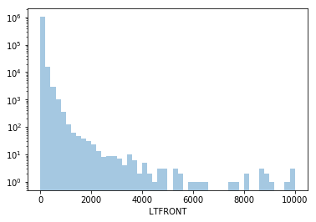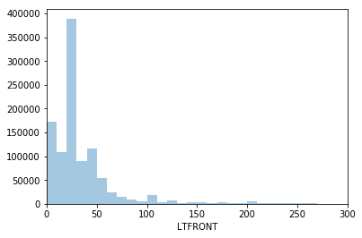

|  |  |  |
| --- | --- | --- |
| **Variable** | **Dtype** | **Description** |
| LTDEPTH | Int64 | Lot Depth in feet. No null values. Zero-value represents a large proportion. |

Top 5 frequent values and counts:

100 457583

0 169888

95 31022

90 19941

80 16414

The distribution plot is shown below. The y-axis in the left plot has been applied with log-transformation. The right one shows a closer look at LTDEPTH from 0 to 300 feet.

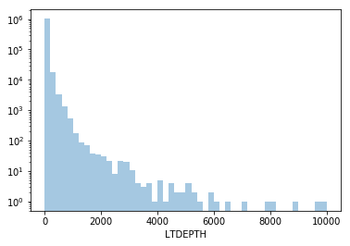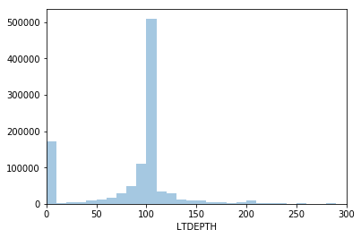

|  |  |  |
| --- | --- | --- |
| **Variable** | **Dtype** | **Description** |
| STORIES | float64 | The number of stories for the building (# of Floors). Involve null values. |

Top 5 frequent values and counts:

2.0 403318

3.0 128493

1.0 93606

2.5 81304

4.0 38337

The distribution plot is shown below. It excludes null values. The y-axis in the left plot has been applied with log-transformation with 20 bins. The right one shows a closer look at STORIES from 0 to 20 floors.

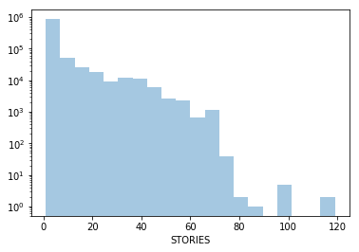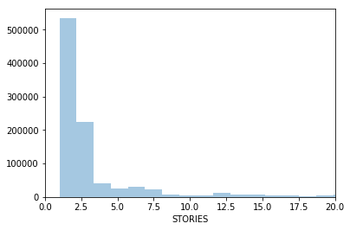

|  |  |  |
| --- | --- | --- |
| **Variable** | **Dtype** | **Description** |
| FULLVAL | Int64 | If not zero, total market value. No null values |

Top 5 frequent values and counts:

0 12762

502000 2751

366000 2260

397000 2189

472000 2179

The distribution plot is shown below. The y-axis in the left plot has been applied with log-transformation. The upper right one also includes log-transformed x-axis. The third plot takes a closer look at values lower than 1,000,000. The last plot adds another limitation which is FULLVAL of non-zero values based on the third plot.

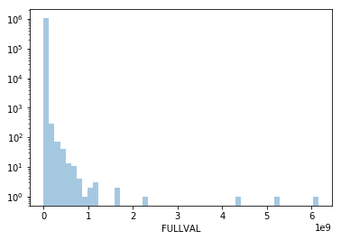 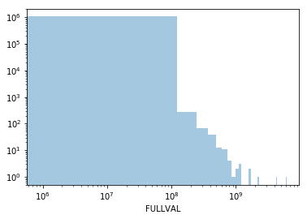

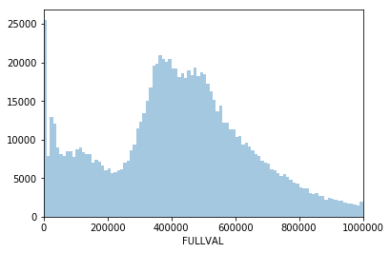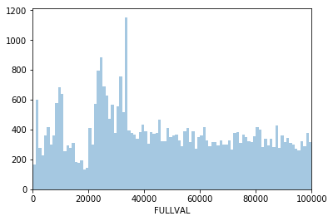

|  |  |  |
| --- | --- | --- |
| **Variable** | **Dtype** | **Description** |
| AVLAND | Int64 | Assessed Land Value. No null values. |

Top 5 frequent values and counts:

0 12764

45000 1225

90000 995

3045 873

22500 825

The distribution plot is shown below. The y-axis in the left plot has been applied with log-transformation. The right one plot takes a closer look at values lower than 50,000.

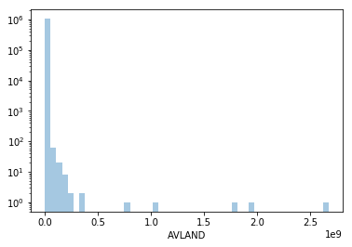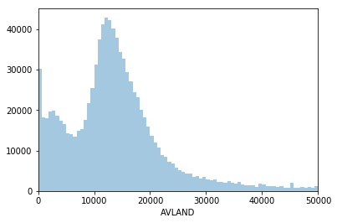

|  |  |  |
| --- | --- | --- |
| **Variable** | **Dtype** | **Description** |
| AVTOT | Int64 | Assessed Total Value. No null values. |

Top 5 frequent values and counts:

0 12762

16588 3111

17914 2953

18973 2447

19780 2435

The distribution plot is shown below. The y-axis in the left plot has been applied with log-transformation. The right one plot takes a closer look at values lower than 100,000.

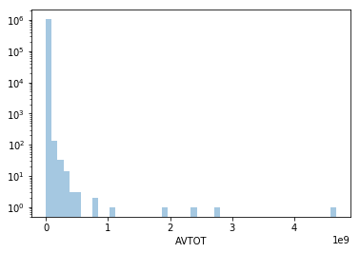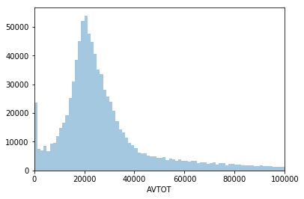

|  |  |  |
| --- | --- | --- |
| **Variable** | **Dtype** | **Description** |
| EXLAND | Int64 | Exempt Land Value. No null values. |

Top 5 frequent values and counts:

0 484224

1620 346604

2090 31111

3240 21181

5760 3365

The distribution plot is shown below. The y-axis in the left plot has been applied with log-transformation. The right one plot takes a closer look at values lower than 15,000 with bins of 25.

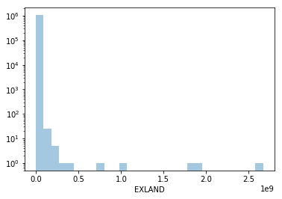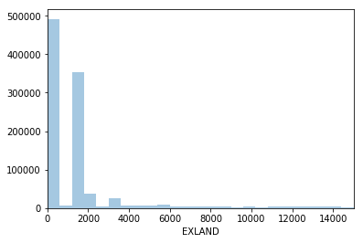

|  |  |  |
| --- | --- | --- |
| **Variable** | **Dtype** | **Description** |
| EXTOT | Int64 | Exempt Total Value. No null values. |

Top 5 frequent values and counts:

0 425999

1620 344273

2090 30068

3240 21436

5760 3353

The distribution plot is shown below. The y-axis in the left plot has been applied with log-transformation. The right one plot takes a closer look at values lower than 10,000 with bins of 20.

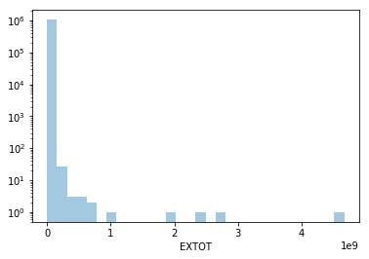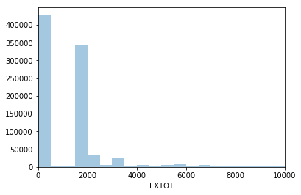

|  |  |  |
| --- | --- | --- |
| **Variable** | **Dtype** | **Description** |
| EXCD1 | Int64 | Involve null values. |

Top 5 frequent values and counts:

1017.0 414222

1010.0 48322

1015.0 30849

5113.0 23842

1920.0 17594

The distribution plot is shown below. It excludes null values. The y-axis in the left plot has been applied with log-transformation with 20 bins in the x-axis.

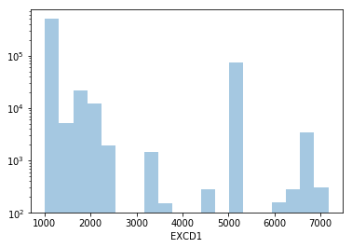

|  |  |  |
| --- | --- | --- |
| **Variable** | **Dtype** | **Description** |
| ZIP | floatt64 | Zip code. Involve large null values. |

Top 5 frequent values and counts:

10314.0 24605

11234.0 20001

10462.0 16905

10306.0 16576

11236.0 15678

The distribution plot is shown below. It excludes null values. The right plot takes a closer look at the ZIP from 10000 to 14000.

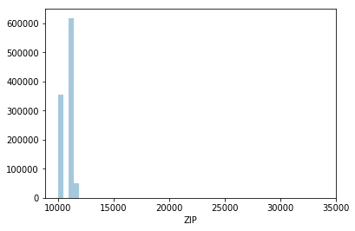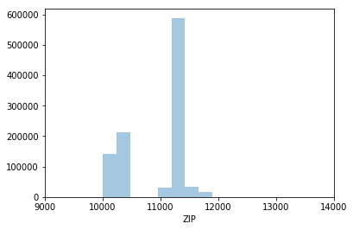

|  |  |  |
| --- | --- | --- |
| **Variable** | **Dtype** | **Description** |
| BLDFRONT | Int64 | Building Frontage in feet. No null values. |

Top 5 frequent values and counts:

0 224661

20 193812

18 76808

16 73671

25 61770

The distribution plot is shown below. The y-axis in the left plot has been applied with log-transformation. The right one plot takes a closer look at values lower than 200 with bins of 100.

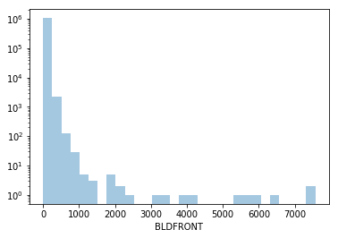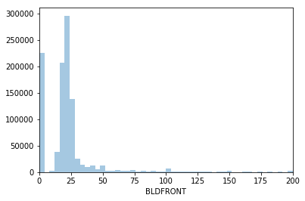

|  |  |  |
| --- | --- | --- |
| **Variable** | **Dtype** | **Description** |
| BLDDEPTH | Int64 | Building Depth in feet. No null values. |

Top 5 frequent values and counts:

0 224699

40 47185

50 44303

36 39514

45 38921

The distribution plot is shown below. The y-axis in the left plot has been applied with log-transformation. The right one plot takes a closer look at values lower than 200 with bins of 50.

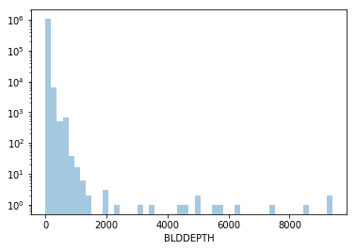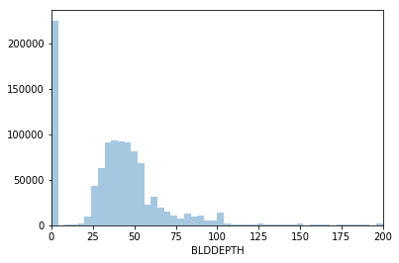

|  |  |  |
| --- | --- | --- |
| **Variable** | **Dtype** | **Description** |
| AVLAND2 | float64 | Assessed Land Value 2. Contains null values. |

Top 5 frequent values and counts:

2408.0 767

2233.0 610

45000.0 596

750.0 547

90000.0 511

The distribution plot is shown below. It excludes null values. The right plot takes a closer look at the AVLAND2 smaller than 100,000.

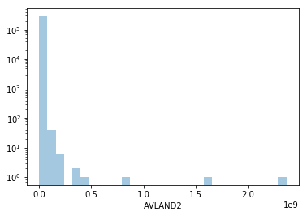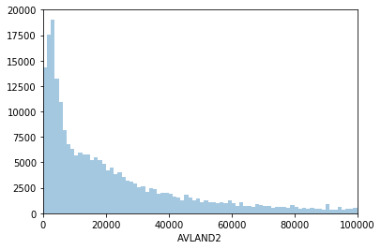

|  |  |  |
| --- | --- | --- |
| **Variable** | **Dtype** | **Description** |
| AVTOT2 | float64 | Assessed Total Value2. Contains null values. |

Top 5 frequent values and counts:

750.0 656

9468.0 233

9104.0 232

9349.0 225

9687.0 215

The distribution plot is shown below. It excludes null values. The right plot takes a closer look at the AVTOT2 smaller than 300,000.

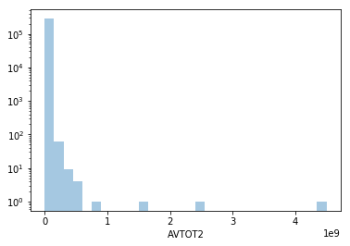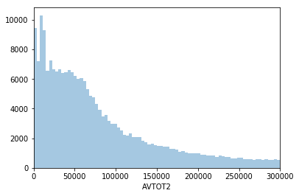

|  |  |  |
| --- | --- | --- |
| **Variable** | **Dtype** | **Description** |
| EXLAND2 | Float64 | Exempt Land Value 2. Contains null values. |

Top 5 frequent values and counts:

2090.0 26393

4180.0 734

2650.0 390

62640.0 192

126180.0 150

The distribution plot is shown below. It excludes null values. The right plot excludes the OUTLIER and takes a closer look at the EXLAND2 smaller than 50,000. The third plot excludes the OUTLIER 2090.0 and takes a closer look at the EXLAND2 smaller than 10,000.

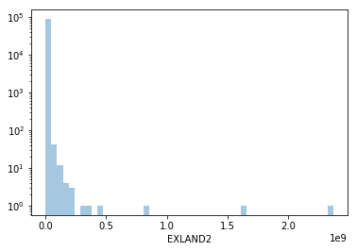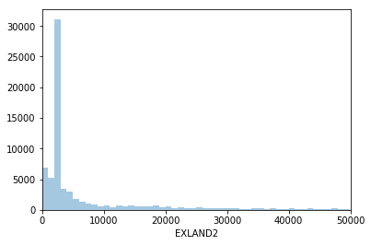

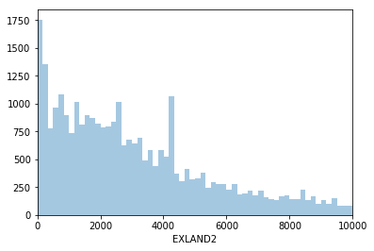

|  |  |  |
| --- | --- | --- |
| **Variable** | **Dtype** | **Description** |
| EXTOT2 | float64 | Exempt Total Value. Contains null values. |

Top 5 frequent values and counts:

2090.0 26393

4180.0 734

2650.0 390

62640.0 192

126180.0 150

The distribution plot is shown below. It excludes null values. The right plot excludes the OUTLIER 2090.0 and takes a closer look at the EXTOT2 smaller than 300,000. The third plot excludes the OUTLIER 2090.0 and takes a closer look at the EXTOT2 smaller than 10,000.

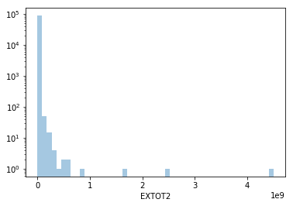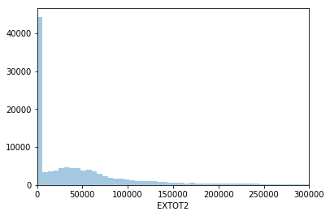

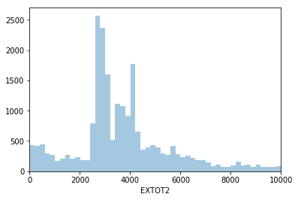

|  |  |  |
| --- | --- | --- |
| **Variable** | **Dtype** | **Description** |
| EXCD2 | float64 | Contains null values. |

Top 5 frequent values and counts:

1017.0 64223

1015.0 12038

5112.0 6867

1019.0 3034

1920.0 2961

The distribution plot is shown below. It excludes null values. The right plot takes a closer look at the EXCD2 smaller than 10,000.

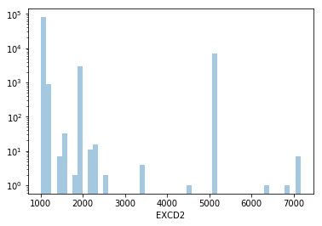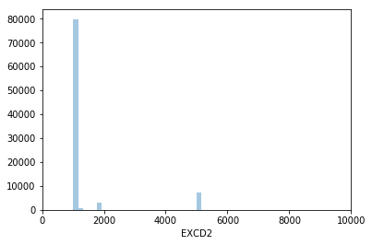

**Categorical variables**

|  |  |  |
| --- | --- | --- |
| **Variable** | **Dtype** | **Description** |
| BBLE | object | Concatenation of other variables. |

Top 10 frequent values and counts:

2027120134 1

1012621010 1

2050550044 1

3002340031 1

3039240059 1

4135130007 1

3007571205 1

5054590087 1

2037620049 1

4136990026 1

Thus, each BBLE remains unique in the data.

|  |  |  |
| --- | --- | --- |
| **Variable** | **Dtype** | **Description** |
| BLOCK | object | Blocks. |

The distribution plot of top 10 frequent BLOCKs is shown below.

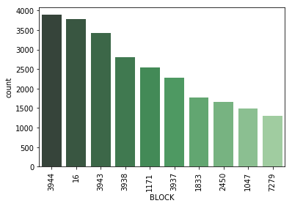

|  |  |  |
| --- | --- | --- |
| **Variable** | **Dtype** | **Description** |
| LOT | object | Lots. |

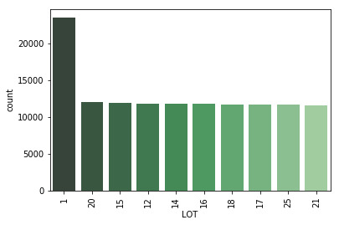

|  |  |  |
| --- | --- | --- |
| **Variable** | **Dtype** | **Description** |
| EASEMENT | object | Is a field that is used to describe easement. |

The distribution plot is shown below. The y-axis in the plot has been applied with log-transformation.

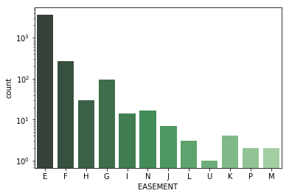

|  |  |  |
| --- | --- | --- |
| **Variable** | **Dtype** | **Description** |
| OWNER | object | The owner’s name |

The distribution plot is shown below. The plot only shows the top 10 frequent OWNER.

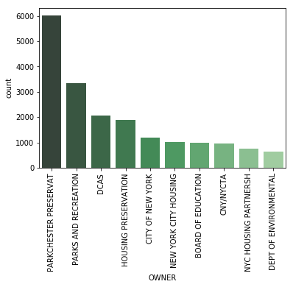

|  |  |  |
| --- | --- | --- |
| **Variable** | **Dtype** | **Description** |
| BLDGCL | character | Building class. |

The distribution plot is shown below. The plot shows the top 15 frequent BLDGCLs.

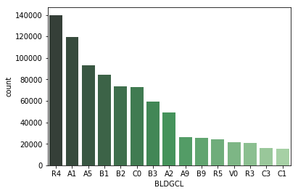

|  |  |  |
| --- | --- | --- |
| **Variable** | **Dtype** | **Description** |
| TAXCLASS | object | Current Property Tax Class Code. There is a direct correlation between the Building Class and the 1st position of the Tax Class |

The distribution plot is shown below. The y-axis in the plot has been applied with log-transformation.

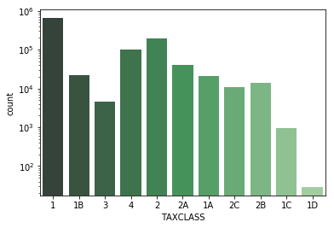

|  |  |  |
| --- | --- | --- |
| **Variable** | **Dtype** | **Description** |
| STADDR | character | Street Address |

The distribution plot is shown below. The plot shows the top 15 frequent STADDRs.

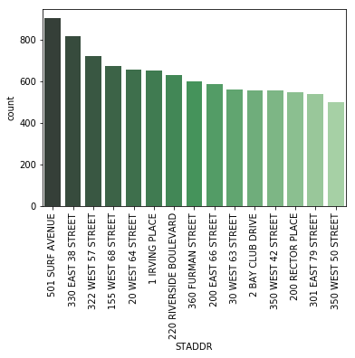

|  |  |  |
| --- | --- | --- |
| **Variable** | **Dtype** | **Description** |
| EXMPTCL | character | Exempt Class used for fully exempt properties only. |

The distribution plot is shown below. The y-axis in the plot has been applied with log-transformation.

